Defuse the Bomb A CSC 102 Project
Team Group Members: Jake Calderon, John Krikorian, Declan Lustenberger, Chevaughn Hanson
BOMB DEFUSAL MANUAL
The Game This project is based on the game Keep Talking and Nobody Explodes [1], a cooperative bomb defusing party game. As the game designers put it, “You’re alone in a room with a bomb. Your friends, the 'Experts', have the manual needed to defuse it. But there’s a catch: the Experts can’t see the bomb, so everyone will need to talk it out – fast! Put your puzzle-solving and communication skills to the test as you and your friends race to defuse bombs quickly before time runs out!”
Their version is a software game. Our version takes the idea and realizes it as a physical device with buttons, switches, and more! Although our version can be played just like theirs, players can interact with both the bomb and this document at the same time (i.e., players can both defuse the bomb and serve as the “Experts”, using this document to help disarm the phases).
The backend of our version of the game is a Raspberry Pi [2] computer that combines a typical computer with the ability to interact with the outside world through sensors. The underlying software is written in Python [3] and is the result of a final group-based project in CSC 102 (The Science of Computing II) in the Computer Science Program at the University of Tampa.
Story Synopsis You are a specialized bomb squad called in to handle a highly sensitive situation. A mysterious villain has planted these complex explosive devices around the city, and you must systematically defuse them before they cause mass damage. Alternatively, perhaps you are dealing with an ancient, booby-trapped artifact, or astronauts trying to restabilize a spaceship's life support systems. Regardless of the scenario, the objective remains the same: disarm all modules before the countdown expires.
Defusing Bombs The bomb will “explode” when its countdown timer, which starts at exactly 300 seconds (5 minutes), reaches 0:00 or when too many strikes have occurred. You defuse the bomb by disarming all its “phases” before the countdown expires.
Phases The bomb has three phases (Keypad, Wires, and Toggles), each of which must be disarmed to defuse the bomb. The phases can be disarmed in any order. Once a phase is disarmed, it becomes inactive and changing it doesn't affect the bomb. Instructions for disarming the phases are provided in this document.
Strikes When the bomb defuser makes a mistake, the bomb will record a strike which will be displayed on the indicator above the countdown timer. Bombs with a strike indicator will explode upon the fourth strike. Additionally, every time a strike is recorded, 15 seconds will be instantly cut away from the available time on the clock, and the timer will begin to count down faster.
Information A different version of the bomb is randomly presented each time it is “booted”. There are 6,720 unique versions of the bomb with a whopping 1,176,000 possible variations! Disarming some phases will require specific information about the bomb. Pay close attention to the “bootup” text on the bomb's screen.

Regarding the Keypad (Phase 1)
To disarm the Keypad phase, you must translate a numerical value into its binary equivalent.
- Observe the screen. A random number between 1 and 100 will appear on the display.
- Determine the correct binary representation of that specific number.
- Enter the correct binary code using the keypad to successfully disarm this phase.

Regarding the Wires (Phase 2)
To disarm the Wire phase, you must analyze the image module presented to you and use the indicator logic to determine the correct pulling sequence.
- The screen will randomly display one of several wire module images (e.g., Module ID: A-17, B-24, C-39, D-58, E-73).
- Look at the "INDICATOR" screen in the top right corner of the displayed image. It will provide a specific mathematical rule or logic statement (such as "RED COUNT + EVEN POSITIONS").
- Use the 5 wires shown on the left side of the image to solve the logic problem presented by the indicator.
- Once you have deciphered the correct wire defusal pattern using the manual's decoding rules, press the button to confirm. Warning: Do not pull the wrong wire. Each mistake counts as a strike.
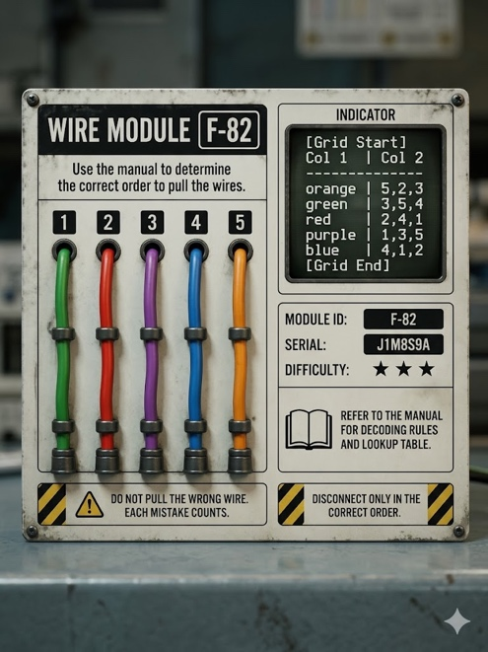
Regarding the Toggles (Phase 3)
To disarm the Toggle phase, you must decode visual signals to manipulate a series of switches.
- The bomb features four toggles, defined from left to right as positions 0, 1, 2, and 3.
- Observe the LED display. The system will use Morse Code combined with specific Colors to give you clues regarding which toggle needs to be flipped.
- Diffuse the correct toggle based on the Morse/Color clues.
- Press the button once to confirm the toggle change.
- Move to the next toggle and repeat the process until all are successfully configured.
Once all three phases have been successfully disarmed, you have successfully defused the bomb!

